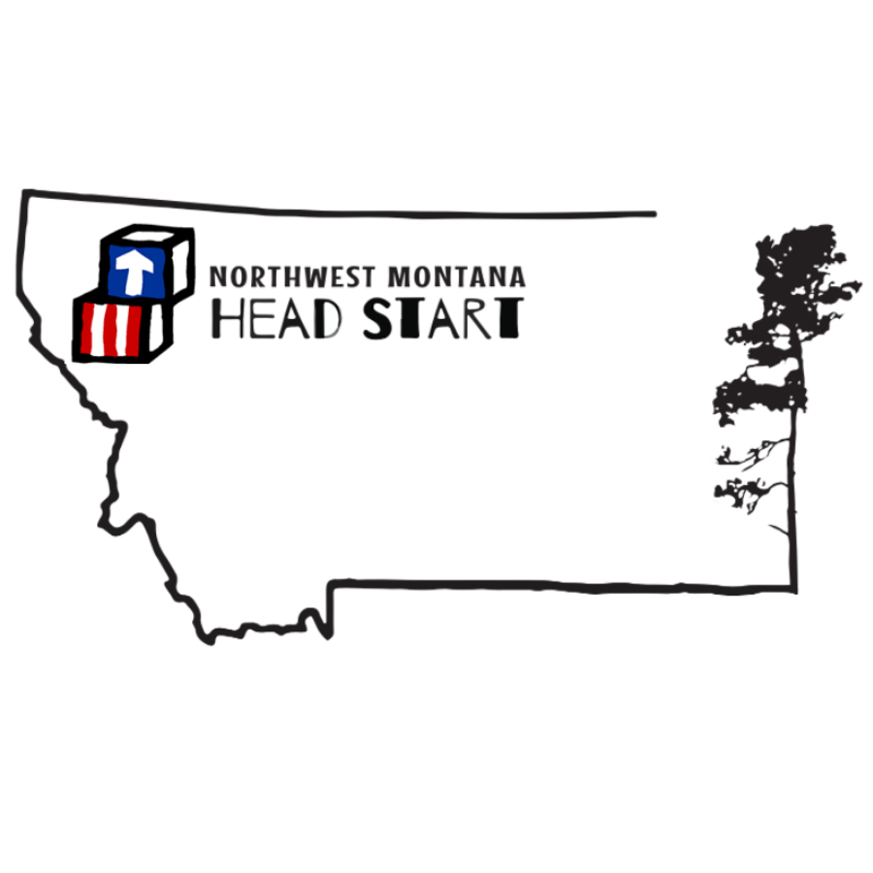
April 2022-2023
mon | tue | wed | thu
03 | 04 | 05 | 06
B: Corn Chex, Oranges, Milk  L: Chicken Nuggets, Mac n’ Cheese, Carrots, Pears, Milk  S: Chips and Corn Salsa, Milk | B: Scrambled Cheesy Eggs, Peaches, Milk  L: Tuna Sandwiches, Carrot sticks, Strawberries, Milk  S: WW Cinnamon Bread, Milk | B: Ham & Cheese English Muffin, Pineapple, Milk  L: Bean Burrito, Green Salad, Apples, Milk  S: Corn Chips, Chickpea Hummus, Milk | B: Baked Oatmeal, Applesauce, Milk  L: Pad Thai, Pineapple, Milk  S: Cheese Quesadilla, Milk
10 | 11 | 12 | 13
B: Cream of the West, Oranges, Milk  L: Chicken Pot-Pie with Biscuit Crust, Peaches, Milk  S: Animal Crackers, Fresh Mellon, Milk | B: *Dyed Hard Boiled Eggs, Cantaloupe, Milk (pm classes)  L: Chickpea Pasta Salad, WW Rolls, Pears, Milk  S: Applesauce Muffins, Milk | B: Banana Bread, Applesauce, Milk  L: Tuna Melts on WW bread, Pickles, Apples, Milk  S: Asparagus Sticks, Dip, Milk | B: Rice Chex, Oranges, Milk  L: Navy Bean and Ham Soup, WW Rolls, Bananas, Milk  S: Pretzels, Cheese Sticks, Milk
17 | 18 | 19 | 20
B: Turkey Sausage Egg Bake, Cantaloupe, Milk  L: Beef Tacos, Green Salad, Oranges, Milk  S: Peanut Butter, Oatmeal Energy Ball, Milk | B: Oatmeal, Peaches, Milk  L: Ham, Scalloped Potatoes, WW Rolls, Pineapple, Milk  S: Pretzels, Veggies, Dip, Milk | B: Ham & Cheese Sandwich, Apples, Milk  L: Baked fish, Rice Pilaf, Broccoli, Watermelon, Milk  S: Ranch Baked Chickpeas, Carrot Sticks, Milk | B: Blueberry Muffins, Applesauce, Milk  L: Creamy Broccoli & Cauliflower Soup, WW Cold Cheese Sands., Bananas, Milk  S: Dried Fruit Trail Mix,Milk
24 | 25 | 26 | 27
B: Oatmeal Berry Swirl, Oranges, Milk  L: Eldorado Casserole, Salad, Pears, Milk  S: Wheat Thin Crackers, Jam, Milk | B: Potato, Veggie, Cheese Egg Bake, Milk  L: Lasagna, Spinach Salad, Cantaloupe, Milk  S: Turkey Deli Slices, Cheese Cubes, Milk | B: Biscuits, Jam, Honey and Mandarin Oranges, Milk  L: Thai Pork Skewers, Rice, Pineapple, Coleslaw, Milk  S: Cream Cheese Tortilla Wrap, Milk | B: Life Cereal, Bananas, Milk  L: Pepperoni Pizza, Carrot Sticks, Apples, Milk  S: Strawberry Bagel Bites, Milk
HOM: |  |  | Make-Up-Day Fri. 07
Chickpeas |  | 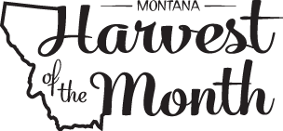  Region/Culture Highlighted:  Thai Land/Thai Food | B: Shredded Mini Wheats, Berries, Milk  L: BBQ Meat Balls, WW rolls, Spinach Strawberry Salad, Milk  S:PBJ’s on WW Bread, Milk

