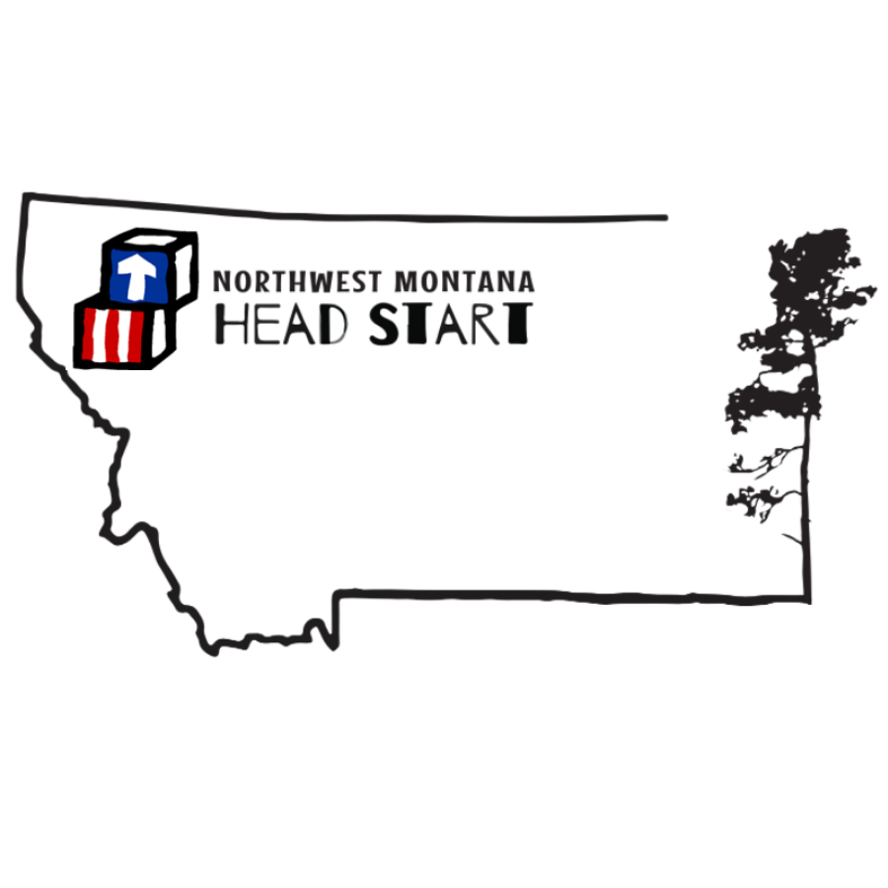
Februar y 2023
mon | tue | wed | thu
HOM: BEETS |  | 01 | 02
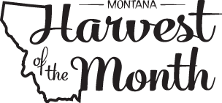 | 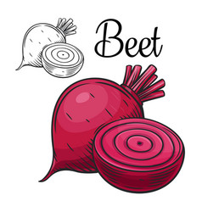 | B: Oatmeal, Peaches, Milk  L: Ham, Scalloped Potatoes, WW Rolls, Pineapple, Milk  S: Chips & Salsa, Milk | B: Swirl Bread, Applesauce, Milk  L: Cold Cheese Sandwiches, Tomato Soup, Grapes, Milk  S: Banana Bread, Milk
06 | 07 | 08 | 09
B: Turkey Sausage Egg Muffin, Pineapple, Milk  L: Beefy Rice Casserole, Carrots & Celery, Plums, Milk  S: Breadsticks, Marinara, Milk | B: Bagel, Mandarin Oranges, Milk  L: Tuna Sandwiches, Cucumbers, Apples, Milk  S: Cottage Cheese, WW Crackers, Milk | B: Cream of Wheat, Peaches, Milk  L: Spaghetti, Green Beans, Pears, Milk  S: WW English Muffin with Peanut Butter, Milk | B: Blue Berry Bran Muffin, Applesauce, Milk  L: Chicken & Wild Rice Soup, WW Crackers, Oranges, Milk  S: BEET Bread, Apple slices, Milk
13 | 14 | 15 | 16
B: Mixed Berry Yogurt Parfait, Milk  L: Sloppy Joes, WW roles, Broccoli, Peaches, Milk  S: Blueberry Bagels & Cream Cheese, Milk | B: Corn Chex, Pears, Milk  L: Drumsticks, Mac n Cheese, Snap Peas, Apples, Milk  S: Peanut Butter Pretzels & Milk | B: Cheesy Scrambled Eggs, Oranges, Milk  L: Pork Yakisoba Noodles, Steamed Broccoli, Pineapple, Milk  S: Walnut Banana Bread, Milk | B: Cream of the West, Strawberries, Milk  L: Turkey, Cheese & Lettuce Sandwiches, Cucumbers, Bananas, Milk!  S: Chex Mix, Milk
20 | 21 | 22 | Moms for Muffins 23
No School  President’s  Day | B: Cinnamon Bread, Applesauce, Milk  L: Black Bean Enchiladas, BEET Salad, Peaches, Milk  S: Yogurt, Strawberry parfait, Milk | B: Cranberry Scones, Oranges, Milk  L: Alfredo Cheese Pizza, Broccoli, Pears, Milk  S: Cheese Quesadilla WW, Milk | B: Scrambled Eggs, Muffins, Cantaloupe, Milk  L: Beef Stew, WW Rolls, bananas, Milk  S: BEET Muffins, Milk
27 | 28 |  | FRIDAY Full Day  Make-Up Day 24
B: WW Breakfast Pizza with Pineapple Milk  L: Chicken Penne, Broccoli, Tropical Fruit, Milk  S: WW crackers, Cottage Cheese, Cucumbers, Milk | B: Biscuits, Ham, Pineapple, Milk  L: Baked Ziti, WW rolls, Apples, Milk  S: BEET Smoothies, Graham Crackers, Milk |  | B: Baked WW French Toast, Applesauce, Milk  L: Brown Sugar Glazed Ham, Rolls, Green Salad, Peaches, Milk  S: WW Bagels & Cream Cheese, Milk

