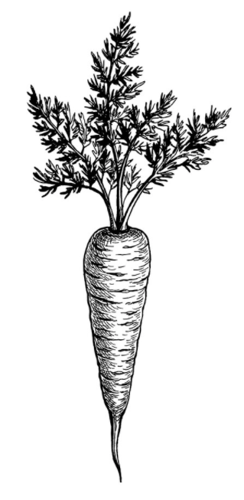
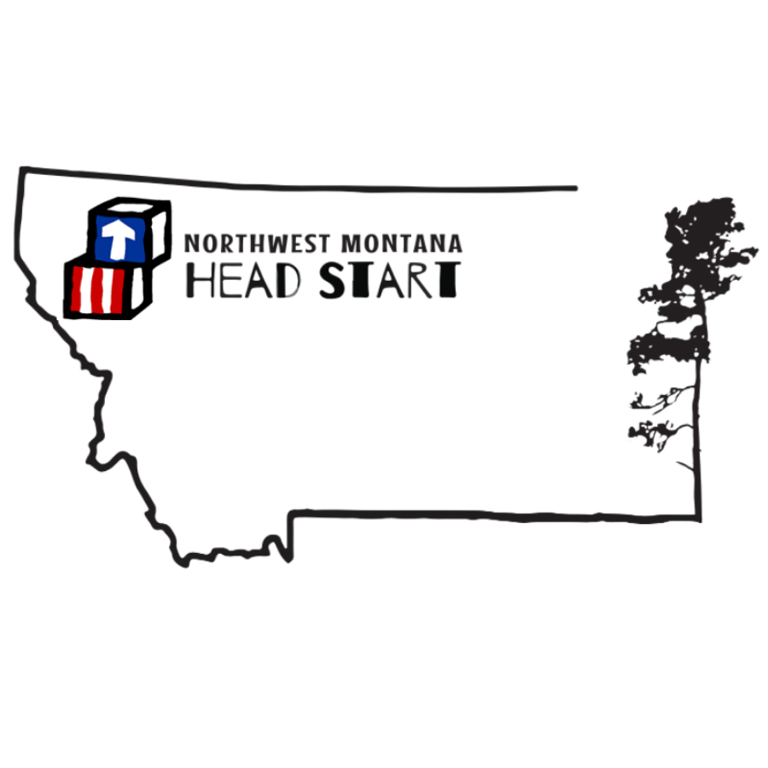
January 2022
mon | tue | wed | thu
NO SCHOOL 03 | 04 | 05 | 06
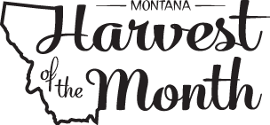  HOM: Carrots | B: Oatmeal, Peaches, Milk  L: Chicken Wings, Mac & Cheese, Carrots, Pears, Milk  S: Pretzels & Cheese, Milk | B: Biscuits and Jelly, Bananas, Milk  L: Sloppy Joes, WW Rolls Salad, Pineapple, Milk  S: Pitta Chips, Milk | B: Kix, Oranges, Milk  L: Potato and Ham Soup, WW Crackers, Apples, Milk  S: Popcorn, Cheese Cubes, Milk
10 | 11 | DUDES DAY 12 | 13
B: Cream of the West, Cantaloupe, Milk  L: Chicken Pot-Pie with Biscuit Crust, Peaches, Milk  S: Kix Cereal, Oranges, Milk | B: Turkey Sausage Egg Bake, Pineapple, Milk  L: Beefy Macaroni Casserole, Salad, Pears, Milk  S: WW Cinnamon Bread, Milk | B: Carrot Bread, Applesauce, Milk  L: Tuna Melts, Pickles, Apples, Milk  S: Ham and Cheese English Muffins, Milk | B: Corn Chex, Oranges, Milk  L: Navy Bean and Ham Soup, WW Rolls, Bananas, Milk  S: Pretzels, Cheese Sticks
NO SCHOOL 17 | 18 | 19 | 20
Martin Luther King Jr. Day | B: Oatmeal, Peaches, Milk  L: Ham, Scalloped Potatoes, WW Rolls, Pineapple, Milk  S: Pretzels, Carrots & Celery, Ranch, Milk | B: Ham & Cheese Sandwich, Apples, Milk  L: Baked fish, Rice Pilaf, Broccoli, Pears, Milk  S: Cinnamon Bread, Milk | B: Carrot muffins, Applesauce, Milk  L: Creamy Broccoli & Cauliflower Soup, Turkey & Cheese Cubes, WW Crackers, Bananas, Milk  S: Trail Mix, Milk
24 | 25 | 26 | 27
B: Honey Nut Cheerios, Oranges, Milk  L: Eldorado Casserole, Salad, Pears, Milk  S: Peanut Butter, Oatmeal Energy Ball, Milk | B: Potato, Veggie, Cheese Egg Bake, Milk  L: Ham and Cheese Sandwiches, Carrot sticks, Mixed fruit, Milk  S: Rice Cakes, Peanut Butter, Apples, Milk | B: Biscuits with Jelly and Honey, Mandarin Oranges, Milk  L: Sweet and Sour Chicken, Rice, Pineapple, Coleslaw, Milk  S: Blueberry Oatmeal Muffins, Milk | B: Oatmeal, Bananas, Milk  L: Pepperoni Pizza Soup, Crackers, Apples, Milk  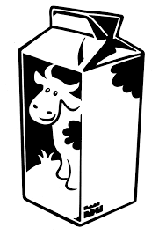  S: Cinnamon Bagel Bites,  Chocolate Milk
31
B: WW Bread, Cottage Cheese, Pears, Milk
L: Beef Tacos, Green Salad, Oranges, Milk
S: Crackers, Cheese Cubes & Apples

