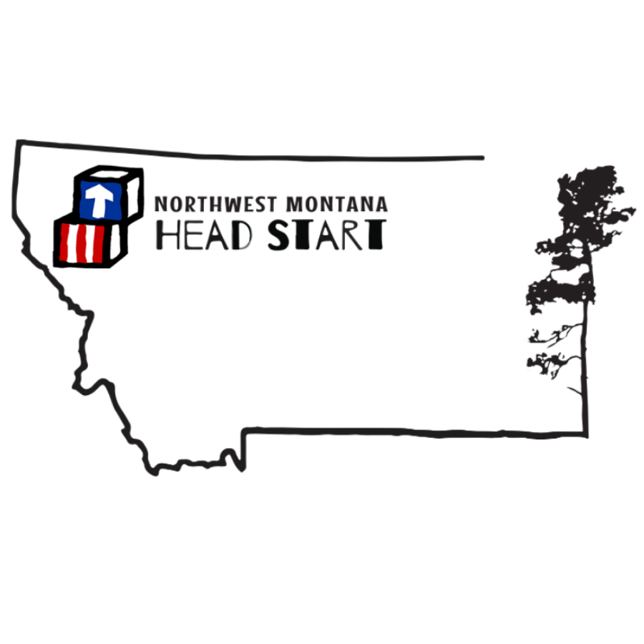
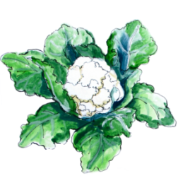
OCtober 2022-2023
mon | tue | wed | thu
03 | 04 | 05 | Stone Soup 06/07
B: Frosted Mini Wheats, Oranges, Milk  L: Cheesy Bean Dip & Tortilla Chips, Salad, Pears, Milk  S: Pretzels, String Cheese, Milk | B: Hard Boiled Eggs, Peaches, Toast, Milk  L: Mini Chicken Dogs, Tater Tots, Carrots & Dip, Milk  S: Fresh Fruit Smoothie, Graham Crackers | B: Biscuits with Jelly and Honey, Mandarin Oranges, Milk  L: Sweet and Sour Chicken, Rice, Pineapple, Coleslaw, Milk  S: Pumpkin Muffins, Milk | B: Breakfast Rice, Bananas, Milk  L: Stone Soup, WW rolls, Mixed fruit, Milk  S: Strawberry Bagel Bites, Milk  *FULL DAY MAKE UP DAY FRIDAY!  (Chief’s Choice)
10 | 11 | 12 | 13
B: Turkey Sausage Egg Muffin, Pineapple, Milk  L: Beefy Rice Casserole, Carrots & Celery, Plums, Milk  S: Cottage Cheese, WW Crackers | B: Bagel, Mandarin Oranges, Milk  L: Refried bean Tostadas, Salsa, Sour Cream, Mellon, Milk  S: Breadsticks, Marinara | B: Cream of Wheat, Peaches, Milk  L: Spaghetti, Green Beans, Pears, Milk  S: WW English Muffin with Peanut Butter, Milk | B: Blue Berry Bran Muffin, Applesauce, Milk  L: Winter Vegetable Bean Soup with Noodles, WW Crackers, Oranges, Milk  S: Banana Bread, Apple slices
17 | 18 | 19 | 20
B: Mixed Berry Yogurt Parfait, Milk  L: Sloppy Joes, WW roles, Broccoli, Peaches, Milk  S: Cheese Quesadilla, Milk | B: Corn Chex, Pears, Milk  L: Chicken Enchiladas, Green Salad, Peaches  S: Carrots, Peanut Butter & WW Crackers | B: Cheesy Scrambled Eggs, Oranges, Milk  L: BBQ Chicken Pizza, Green Salad, Pineapple, Milk  S: Zucchini Bread, Milk | B: Cream of the West, Strawberries, Milk  L: Turkey and Cheese Sandwiches, Cucumber Slices, Apples, Milk  S: Chex Mix, Milk
24 | 25 | 26 | 27
B: Biscuits, Ham, Pineapple, Milk  L: Goulash, Gingered Cabbage Salad, Milk  S: Cheese, WW Crackers | B: Cinnamon Bread, Applesauce, Milk  L: Chicken Nuggets, Mac n Cheese, Snap Peas, Apples, Milk  S: Yogurt, Strawberry Parfait | B: Scrambled Eggs, WW Bread, Cantaloupe, Milk  L: Cold Ham & Pea Pasta Salad, WW Rolls, Peaches, Milk  S: Cheese Quesadilla WW, Milk | B: Cranberry Scones, Oranges, Milk  L: Taco Soup, Tortilla Chips, Bananas, Milk!  S: Chex Mix, Milk
Halloween 31 |  |  | -BRASSICAS-
B: Super Power Smoothies, Toast, Milk  L: Spooky Tuna Sandwiches, Cucumbers, Cuties, Milk  S: Pumpkin Bread, Apples, Milk | 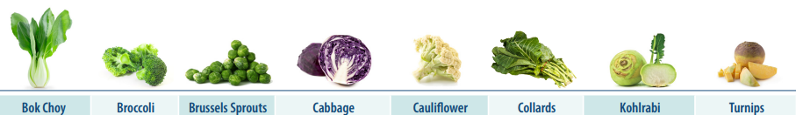  Region/Culture Highlighted:  Mexico/Latin America |  | 